This Trick is Probably the Most Important Thing you Need to Know About Debugging Tests and Code!

Here is a quick overview…
- F9 – on a line of code in the test
- Right click on the test and select debug test
- F10 to step through line by line
- F11 to step into any middle layer code

So, let’s work through an example.
Press F9 in your test to generate a break point like so…
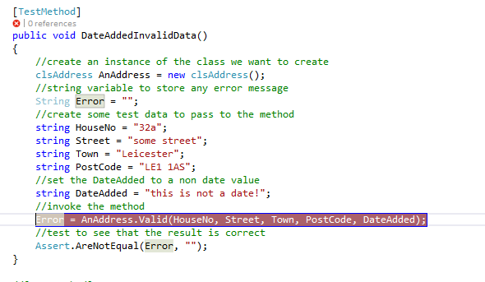

Now right click on the test and select debug tests…
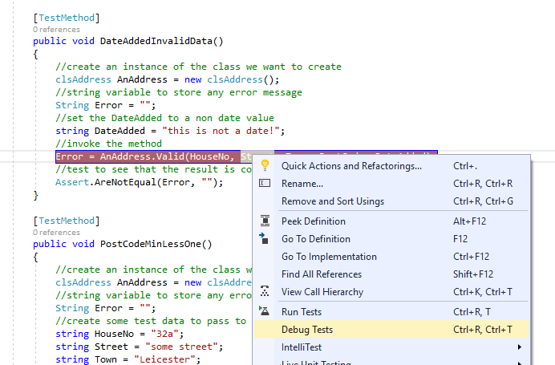

Visual Studio should then stop at the break point with yellow highlighting…
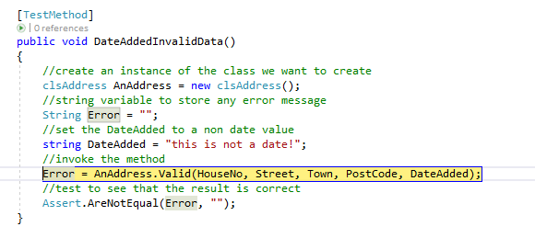
Press F11 to step into the middle layer code for the validation method.
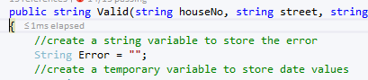

Now press F10 to step line by line through the function.
When the following line is highlighted, stop and inspect the data value about to be assigned…

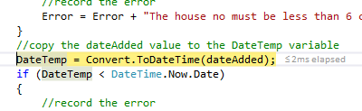
To inspect the value of any variable just hold the mouse over the variable and the debugger will tell you what data it contains.
The string variable DateAdded contains the text data “this is not a date!”.
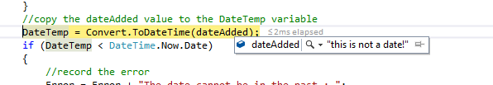
The assignment operation is about to convert that data to a date value and assign it to the variable DateTemp.
Here is where the problem lies.
Press F10 one more time and watch the program crash…

